Final Exam

CSCI 4310/6323 (Design and Analysis of Algorithm), Dr. Bin Fu
Due 11:59pm Sunday May 2, 2021(Sunday).
Please submit your solution in MS word format with file name firstname-lastname-final.doc to the Blackboard.

Name: Ulvi Bajarani ID: 20539914 Email: ulvi.bajarani01@utrgv.edu

Problem 1. Given the graph below, apply Bellman-Ford algorithm to find the lengths of shortest paths from s to all other nodes. Show how those length values change at each stage of the algorithm.

1

3 5 1
s
2 1

9 3

Answer 1. The images below describes step-by-step execution of Bellman-Ford algorithm in |V-1|=|5-1|=4 steps. The final result is in the final step.
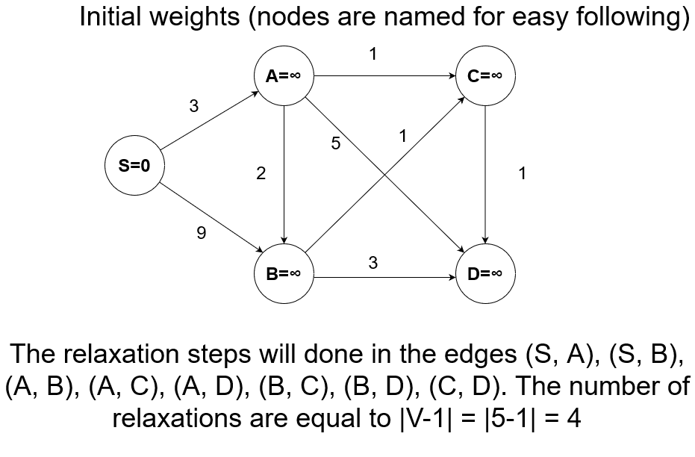

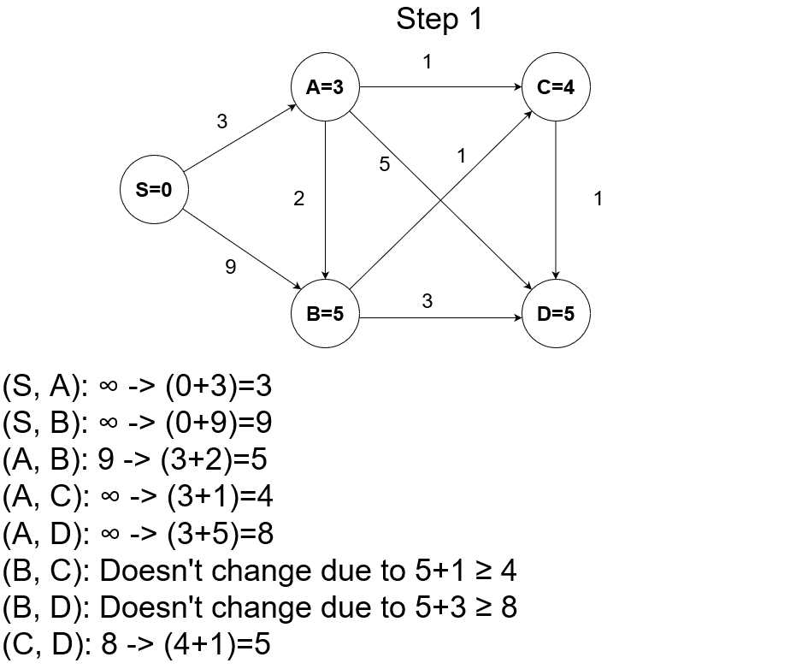
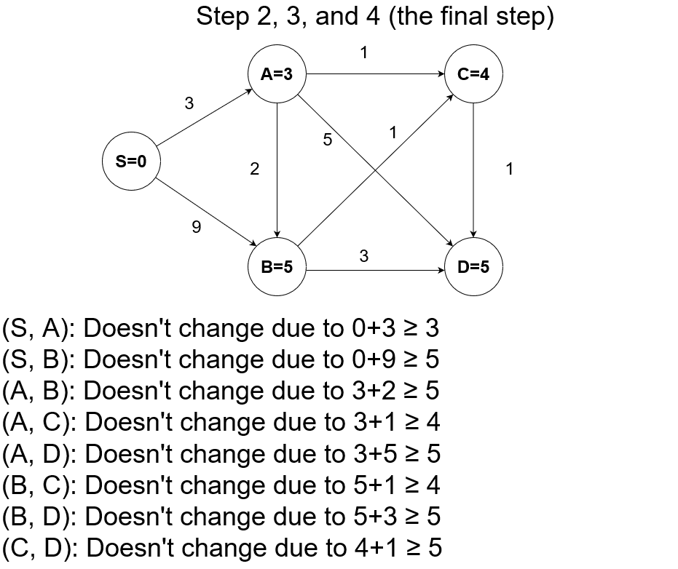
Problem 2.
a). Explain the class NP.
b). Describe the notion of NP-completeness.
c). Describe the notion of polynomial time reduction.
d). Find a polynomial time reduction from the Clique problem to the following half clique problem: Given a graph G of n vertices, determine if G contains a clique of size at least n/2. (Note: a clique of size k in a graph G is a subset S of k vertices such that every two vertices in S shares an edge).

Answer 2.

a) The class NP is the class of problems that can be verified in the polynomial-time by some certificate. In other words, the language L is in NP if for input x, certificate y, and constant c, and verifier V, and n steps, it satisfies the notion below.

L = { V(x, y) = O(n^{c}), x is in L }

There is another definition of the NP-class that could be known from the CSCI 6339 class: The problem is in NP if it either can be decided in Non-Deterministic Turing Machine in the Polynomial time or can be verified in Deterministic Turing Machine in the Polynomial time.

b) We can say that the problem X is NP-complete if both properties exist:

1) The problem X is in NP;
2) For any other problem Y in NP, there is the polynomial time reduction Y→X.

c) Polynomial Time Reduction is the reduction such that for the acceptable input x for problem L₁ transforms to the input f(x) for problem L₂ for the polynomial time O(n^{c}) for some constant c. In this case, L₂ accepts f(x) if and only if L₁ accepts x.

d) From the clique G with n vertices and k-clique, half-clique H is constructed. Three cases are possible:

1) If k = floor(n/2), then we have the output G. G is clique if and only if G is a minimum-clique;

2) If k < floor(n/2), then new graph G’ is constructed by adding a complete graph with n -2k vertices and connecting them to all vertices in G. If G has a k-clique, then G’ has a clique with size n-k . Therefore, G’ is in half-clique since G has n+n-2k=2(n-k) vertices. Conversely, if G’ is in minimum-clique, then it has a clique with n-k = k+(n-2k) size, meaning that at most (n-2k) vertices are from G’ and at least k-vertices form the clique in G. Therefore, G has a clique.

3) If k > floor(n/2), then new graph G’’ is constructed by adding a complete graph with 2k-n 0-degree vertices to G. If G has the k-clique, G’’ has the size k . Consequently, G’’ is in half-clique. Conversely, if G’’ is in minimum-clique, then it has the clique with size k and does not contain any of new vertices, because the vertices has the degree 0. Therefore, G has a clique.
Problem 3.
a) What is the ratio of an approximation algorithm?
b) Given a directed graph G=(V, E), pick a maximum cardinality set of edges from E so that the result graph is acyclic. The left graph below has a directed cycle, but the right graph does not have any directed cycle. So, the right graph is acyclic.
Give a ratio ½ approximation algorithm for this problem. Give and prove the computational time and approximation ratio.

Hint: Arbitrarily number of the vertices and pick the bigger of the two sets, the forward-going and the back-going edges.
2
4
5
3

11

Answer 3.

a) The approximation ratio of the algorithm k is the constant such that C_{APPROX} / C_{OPT} ≤ k. In other words, it describes how the approximation is different than the optimal solution.

b) The required algorithm could be written in the following manner:

Enumerate nodes from 1 to n;
Define empty set FS = {};
Define empty set BS = {};
Visit all edges:
If an edge N is backward-going:
set BS = {N} ∪ BS;
Else if an edge N is forward-going:
set FS = {N} ∪ FS;
Until there is no visited edge.
Return biggest set between BS and FS;

As it might be seen, visiting all edges requires at most O(|E|) time, which is the time complexity of the algorithm (for example, Tarjan’s algorithm might be used for this). The reason why the algorithm has ½ approximation ratio is that at least n/2 of the edges are forward-going. Otherwise, the graph has cycles.
Problem 4.
a) Define the notion of polynomial time factor c-approximation.
b) Design a polynomial time factor (ln n)-approximation for the minimum dominating set problem. For an undirected graph G(V, E), a dominating set U is a subset of V such that each vertex in V is adjacent to a vertex in U via an edge in E.

Hint: Identify its link to the set cover problem.

u
v

w

x

For example, {w} is a dominating set in the graph above (but it is not a vertex cover).

Answer 4.

a) If the problem has the (1+c)-approximation for any fixed c > 0, it has polynomial-time approximation scheme. In this case, the approximation runs in polynomial time, and C_{APPROX} / C_{OPT} ≤ (1+c). This is the compromise between running time and the approximation.

b) The required algorithm could be written in the following manner:

Create the empty set U;
Repeat:
Choose the node N of G that has the highest degree;
set U = {N} ∪ U;
Remove the node N and all neighbors of N from G;
Until there is no node in G;
Return U;

Since we need at most |V| iterations, where at most |V| nodes are deleted, the time complexity is polynomial. Also, due to the fact that the node N is deleted only in the case when either the node N itself or its neighbors are added to U, after all iterations, either every node in the set U, or adjacent to ot. Now let’s prove that the algorithm above gives lnn approximation:

Assume there is the graph G with n nodes and domination size k. To dominate, the set U must contain the node with degree (n/k)-1; otherwise, it could dominates only on the number of nodes fewer than (k[n/k]-1+1) = n. So, the set U dominates containing k nodes and neighboring with the number of nodes fewer than (k[n/k]-1) = n-k. When the node N with the highest degree is added, the degree of such node is equal to at least [n/k]-1. Therefore, the number of deleted nodes is at least [n/k]. After adding the node N to the set U, the new graph to be covered contains n-[n/k]=n(1-[1/k]) nodes. After adding r nodes, we will have n(1-[1/k])^{r} nodes uncovered. The maximum number of uncovered nodes could be found by the equation:

n(1-[1/k])^{r} < 1

This is done after adding r=klnn nodes, since the number of nodes are integers. Therefore, our approximation ratio is at most C_{APPROX} / C_{OPT} ≤ lnn .
Problem 5. Design a randomized algorithm such that given an array a[. ] of n numbers, in which at least 10% numbers are equal to 1, the algorithm returns a position j with a[j]=1. The algorithm should run in constant time O(1). What is the number of steps if the failure probability is more than a prescribed parameter h? The number of steps should depend on the parameter h.

Answer 5. The required algorithm could be written in the following manner:

Set j = “None”.
for i from 1 to k:
Randomly select a[x] such that x ≤ n;
If a[x] = 1:
set j = x;
break;
Return j;

Since the probability of A[j] == 1 is 0.1, the failure rate is 1-0.1=0.9. Therefore, the failing probability is 1-[0.9]^{k} where k is the number of iterations. Since k is constant, the time complexity is O(1). The question is how to choose k with respect to the prescribed parameter h. The solution is in the inequality:

1-(Fail_probability)^{k} ≤ h

The solution with respect to k is:

-(Fail_probability)^{k} ≤ h-1
(Fail_probability)^{k} ≥ 1-h
k ≥ log_{(Fail_probability)}(1-h)

In our case,

k ≥ log_{0.9}(1-h)

So, the minimum bound for k is equal to log_{0.9}(1-h)

